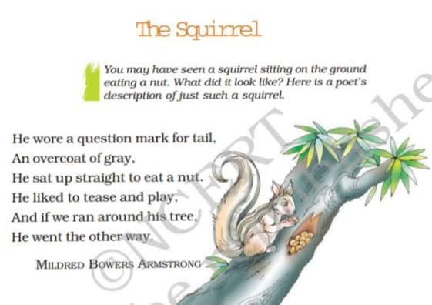
ANALYSIS
Mildred Bowers Armstrong’s poem is a light-hearted and vivid portrayal of a squirrel, capturing its playful nature through simple and engaging language. The poet brings the small creature to life by giving it human-like traits, which makes the poem appealing, especially to young readers. The squirrel is described as wearing “a question mark for tail,” a clever metaphor that captures the shape of its tail while also suggesting its curious and mischievous behaviour.
The line “an overcoat of gray” uses imagery to describe the squirrel’s fur, helping readers visualize the animal clearly. The poem continues with the squirrel sitting up straight to eat a nut, a detail that reflects its alertness and tidy manner. The lines “He liked to tease and play” and “If we ran around his tree, / He went the other way” show the squirrel’s playful, teasing character, creating a sense of movement and fun.
The rhyme and rhythm add to the poem’s cheerful tone, making it easy to read aloud. Literary devices such as metaphor, imagery, personification, and rhyme enhance the poem’s charm. Overall, the poem invites readers to observe and enjoy the small wonders of nature through a childlike lens.

✏️ A metaphor is a figure of speech in which one thing is described as if it were something else, to suggest a resemblance without using “like” or “as.”
Example: “He wore a question mark for tail”
The squirrel’s curled tail is compared to a question mark, not literally but to give a vivid image of its shape and posture.
✏️Imagery involves descriptive language that appeals to the senses, helping the reader to see, hear, smell, taste, or feel something.
Example: “An overcoat of gray”
This line creates a visual image of the squirrel’s gray fur, as if it were wearing a gray coat.
✏️Personification gives human qualities or actions to animals or non-living things.
Example: “He liked to tease and play”
The squirrel is described as if it has the human emotions and intentions to tease and play.
✏️Rhyme is the repetition of similar sounds at the end of lines in poems, usually to create rhythm or musical effect.
Example: “He wore a question mark for tail, / An overcoat of gray, / He sat up straight to eat a nut.”
The words gray and play, nut and cut (if extended), create a rhyme scheme that enhances the poem’s musicality.

Q. Answer the following questions given below :
A. “He wore a question mark for tail,
An overcoat of gray,
He sat up straight to eat a nut.”
Questions
- What does the poet mean by “a question mark for tail”?
- Identify and explain the literary device used in the line “an overcoat of gray.”
- What does the squirrel’s posture while eating suggest about its behaviour?
QB. Explain how the poet's use of playful language creates a lively and engaging image of the squirrel.

